Download Ardunio IDE

<https://www.arduino.cc/en/software>

Use this as a reference to update/select proper COM Port and **Leonardo** arduino board

<https://docs.arduino.cc/software/ide-v1/tutorials/getting-started/cores/arduino-avr/>

The **Leonardo** board is under AVR boards, and if you don’t have that option you can download them from the Boards Manager (Tools>Boards>Boards Manager and search for “Arduino AVR Boards” to install them)

Add/Replace libraries folder in the Arduino Documents Folder or wherever you are saving Arduino projects.

The file needed is Samco_2.0_4IR which is found in the path below

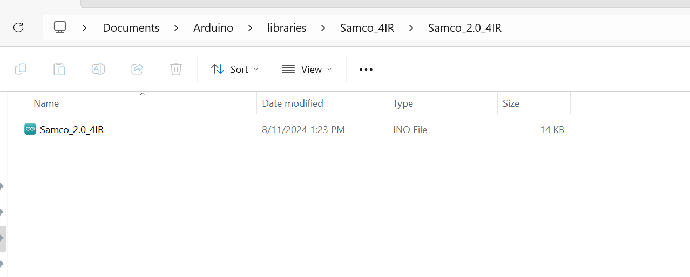

Main things to look at in the file are:

The char variables are the letters being pressed on the keyboard for the distance sensor.

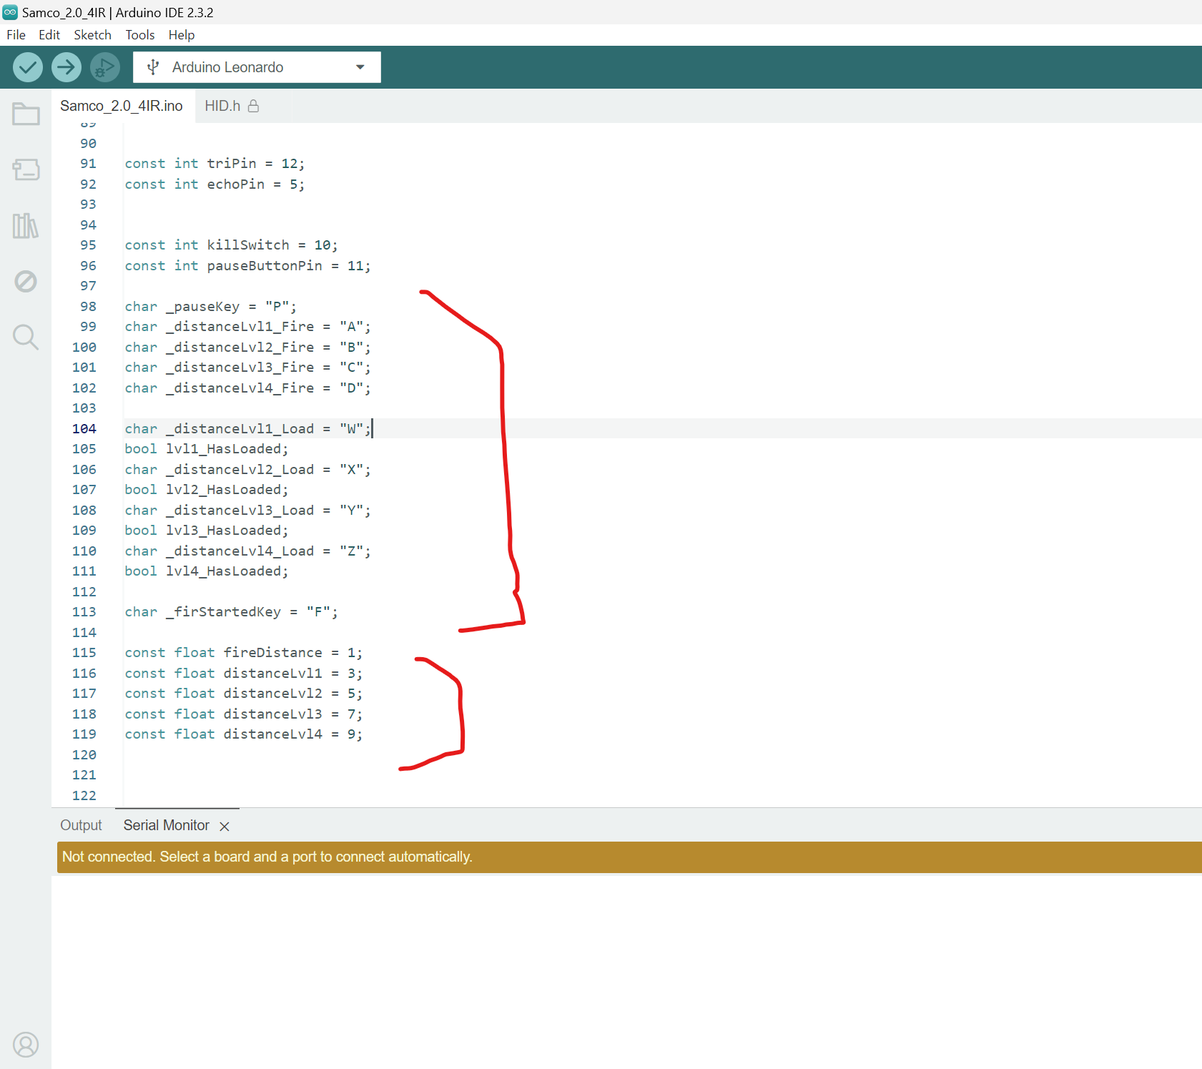

_firStartedKey Activate when player initiates firing by starting to pull back past fireDistance float

_distanceLvl_Load Activate when player is pulling back on the plunger past the set distanceLvl

_distanceLvl_Fire Activate when player lets go of plunger to fire recording the furthest distanceLvl

If you need to check the distance in cm switch the commented out code

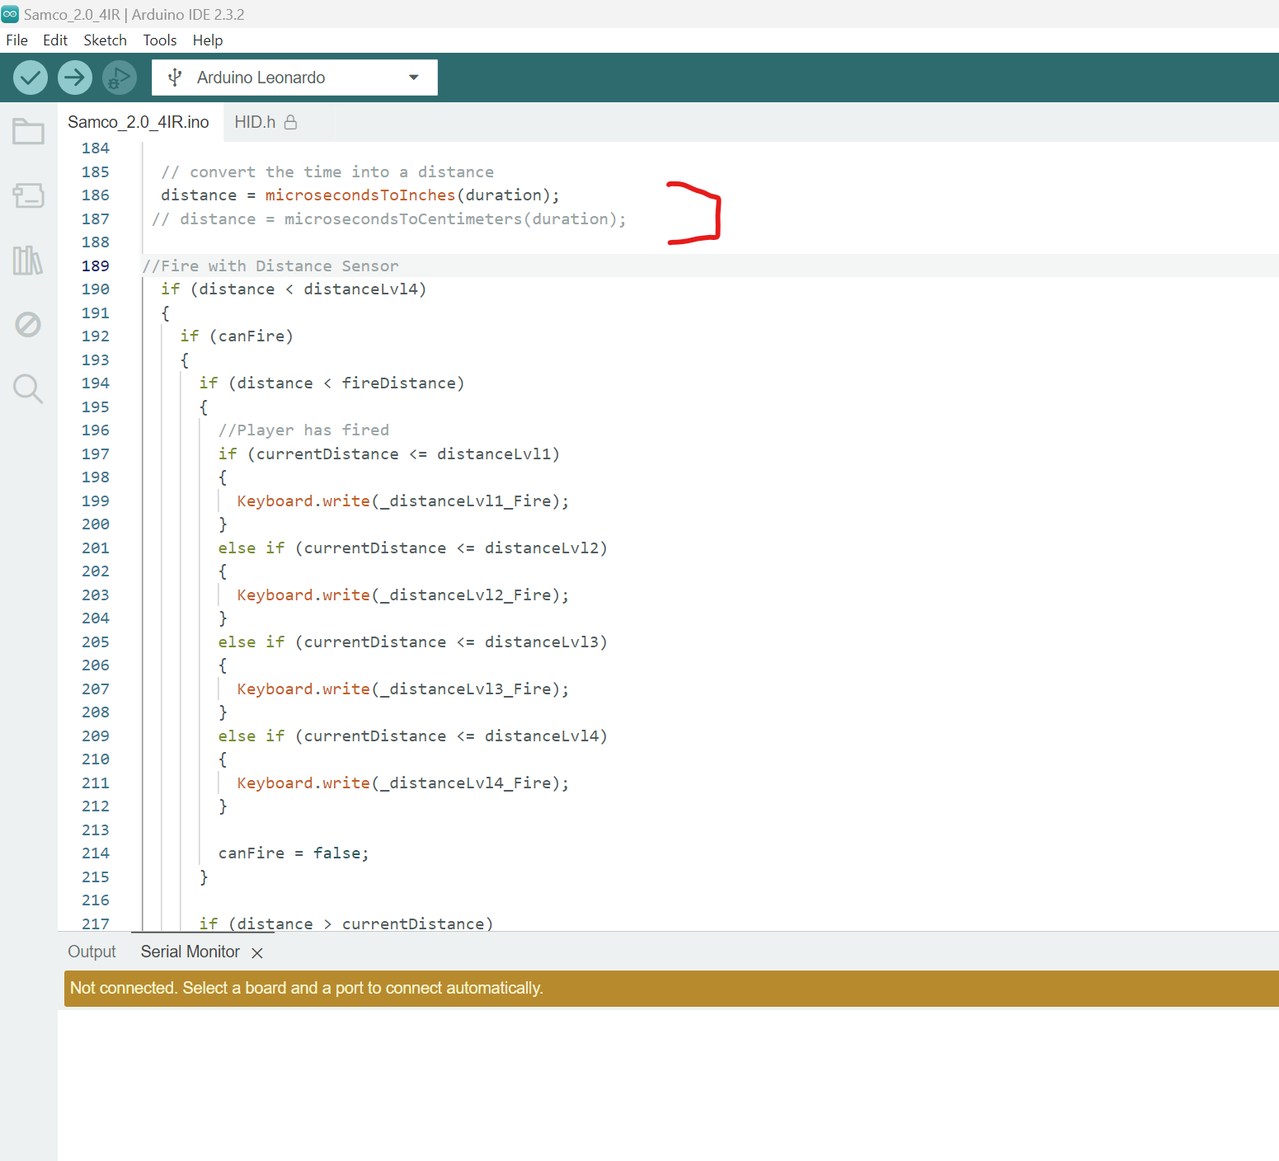

To get an accurate reading on your distance value uncomment the serial.print code and it will read in the Serial Monitor in the Arduino IDE.

